**User's Guide**

**Step 1**

Use your favorite code editor to import the repository superx from the following link- https://github.com/beyond-io/superx.git

**Recommended code editors:**- Pycharm  
- Visual Studio

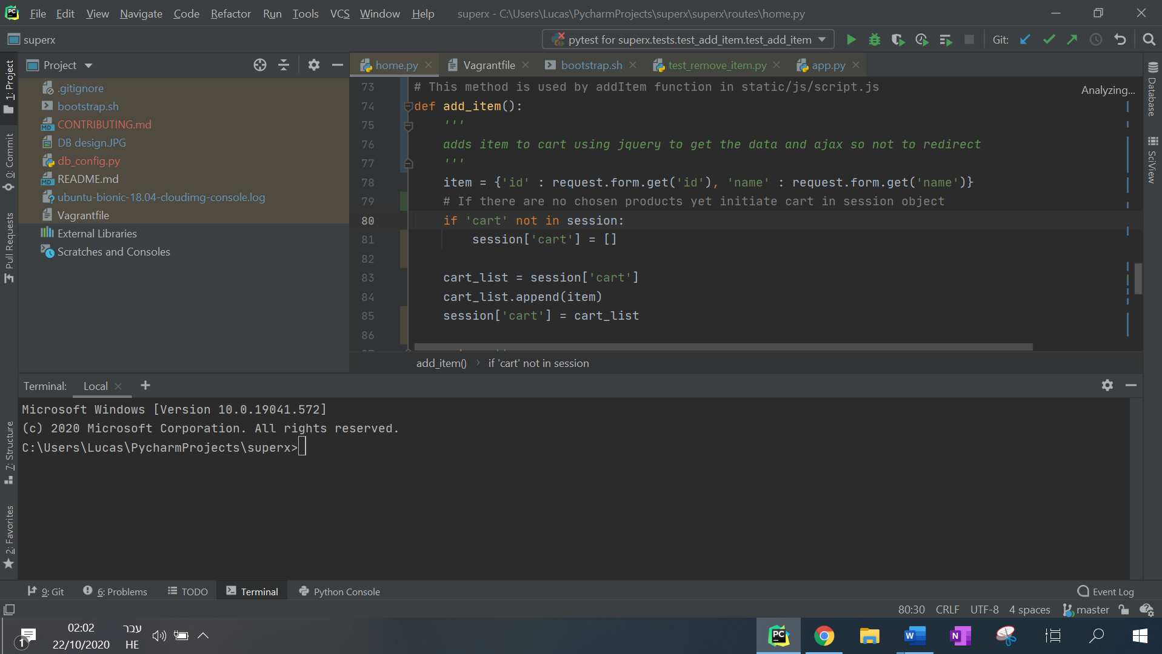

**Step 2**

2. From the terminal / command line, run the virtual machine (where the project is going to run), to do so:  
1. type "**vagrant up**" to create the machine  
2. type "**vagrant ssh**" to connect to the machine  
* If you're having any trouble in your first vagrant command copy this line to your terminal- **Set VAGRANT_HOME=/path/to/vagrant**

**To use vagrant VM download:**  
- Virtual box (Oracle)  
- Vagrant

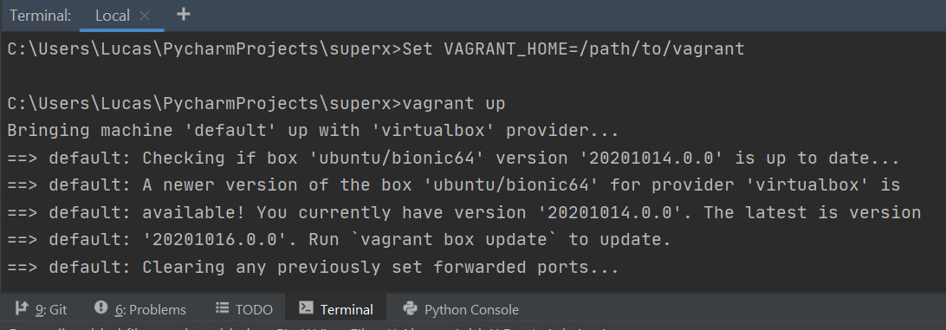Terminal after "vagrant up"

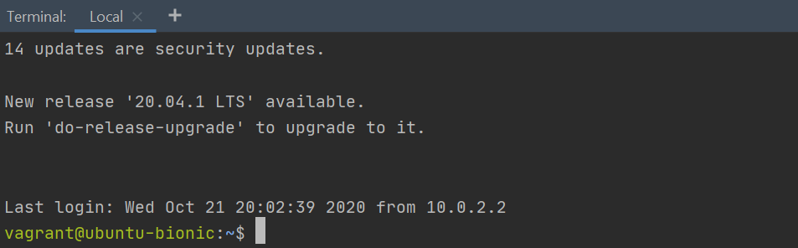Terminal after "vagrant ssh"

**Step 3**

The app is now on air. Go to your browser and type localhost:5000 in the url box.  
You've now entered SuperX price comparison system. You can compare prices of different products based on the city you live in.  
The comparison is between Mega, Shufersal & Victory.

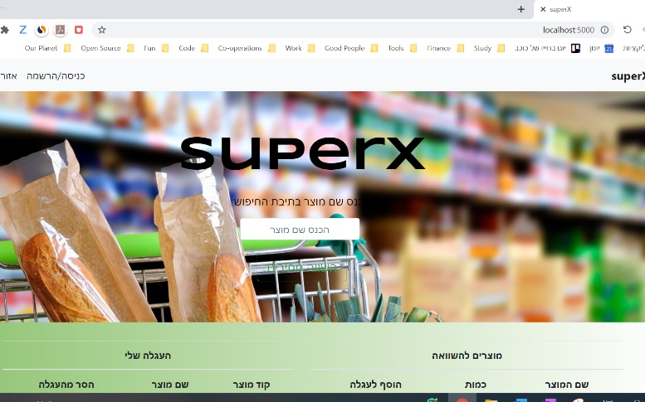

**Step 4**

Type the products you want to compare in the search line, choose the quantity of each, and hit compare. You can now see the cheapest supermarket near you.

**Good luck!**